Motor Vehicle Information
for 2021 Tax Return
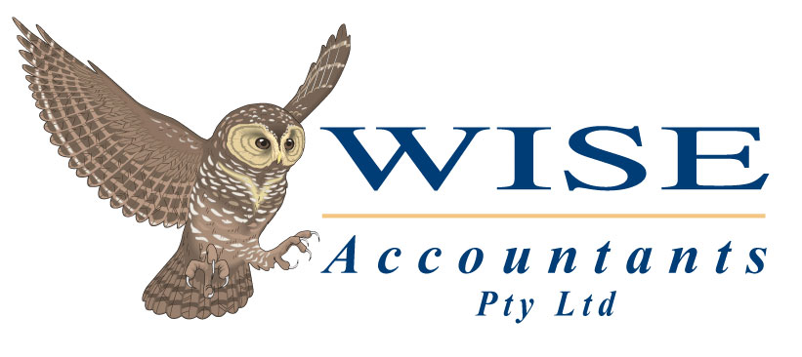

CLIENT NAME: |  | CLIENT SIGNATURE: | X

MOTOR VEHICLE DETAILS
Vehicle Make & Model:
Owner of Vehicle:
Date Purchased: | _____/_______/________ | Purchase Price: | $
Leased Financed (car loan) Paid Cash
Please e-mail, fax or post to our office a copy of your Finance Documents / Lease Agreement (if you haven’t already).
Registration No:

INFORMATION FOR 2021 TAX RETURN IF LOG BOOK IS KEPT
- A log book must contain a record of business use for a continuous 12-week period, which is representative of the car’s usage.
- The information that must be recorded for each business journey is :
- The dates on which the business travel began and ended
- The odometer readings at the start and end of each travel
- The purpose of the business travel with adequate descriptions (such as delivering goods to customers, making house calls)
- A log book is valid for a maximum period of 5 years. A new log book is to be prepared after the expiry of an old log book.
- Please note travel between your home and your workplace is not business travel unless you carry bulky tools
- If you need more information on how to prepare a log book, contact Wise Accountants.
Period Covered on the Log Book: |  |  | From _____/_____/_____ To _____/_____/_____
Business Km in Log Book Period: |  |  | ______________________ km
Total Km in Log Book Period: |  |  | ______________________ km
Calculation of Business Use % on Your Log Book: |  |  | ______________________ %
RUNNING COSTS FOR THE YEAR – 1 July 2020 to 30 June 2021
Fuel: | $ | Insurance: |  | $
Registration: | $ | Repairs & Maintenance: |  | $
Services: | $ | Tyres / Battery: |  | $
RAA Membership: | $ | Parking: |  | $
Tolls: | $ | Other:___________________ |  | $
Payment of car loan | Monthly $_________________ & Annual Total $___________________

INFORMATION FOR 2021 TAX RETURN IF LOG BOOK IS NOT KEPT
Estimated Business Km in 2021 Financial Year (July 2020 to June 2021): | ______________________ km

